**CARRY-A-WAY**

**Sprint 4**

Backend API document

**Backend Developers:**Siva Praneeth  
Shriyans Nidhish

INTERFACE

The idea of Carry-A-way is to provide users with a cheap, convenient, step-by-step tracking and messaging enabled shipping facility for their check in luggage/item/sports/music kit etc. through courier service of their choice and get it picked/delivered at their origin/destination doorstep. All in just few clicks.

Carry-A-way is a web application developed using Go and Angular which allows users to travel hassle free without a worry of carrying bulky luggage/items and paying heavy charges to airlines.

* This document refers to the backend API details that’s developed using Golang.
* The development work is demonstrated in further pages with the help of code snippets and working screenshots.

Table of Contents

Password recovery 3

User sessions 4

Chat 5

Basecost 6

Unit tests 6

TestLoginWrongCred 6

TestLogout: 6

TestLogoutWhenIncorrect: 7

TestForgotPasswordHandler: 7

In this final sprint we have achieved the following pertaining to backend:

## Password recovery

One of the major API functionalities achieved in the backend area is the ability of user to recover password.

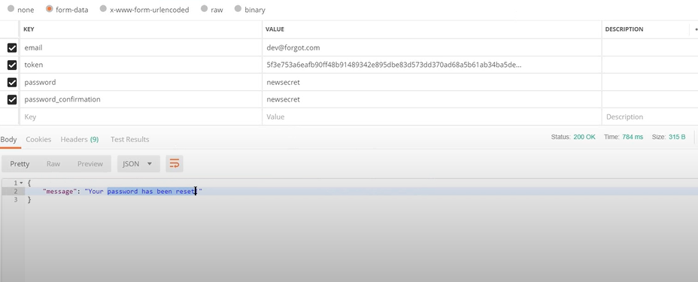

API: <http://localhost:8000/forgotpw>

Method: POST

Status: 200->OK

If any other incompatible data is sent:

404->Error

401->Unauthorized

429->Too many requests

## User sessions

Sessions can be tracked based on cookies stored in the d

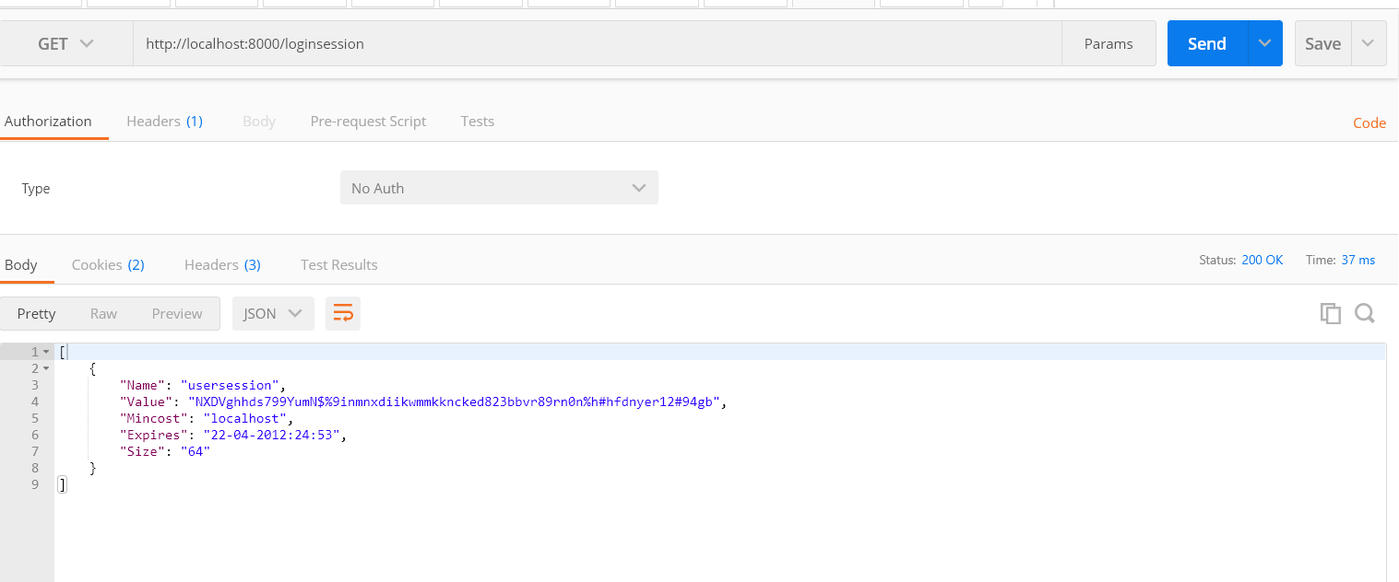

API: http://localhost:8000/loginsession

Method: GET

Status: 200->OK

If any other incompatible data is received:

404->Error

401->Unauthorized

429->Too many requests

Cookies created as part of user sessions are stored and displayed in postman as follows

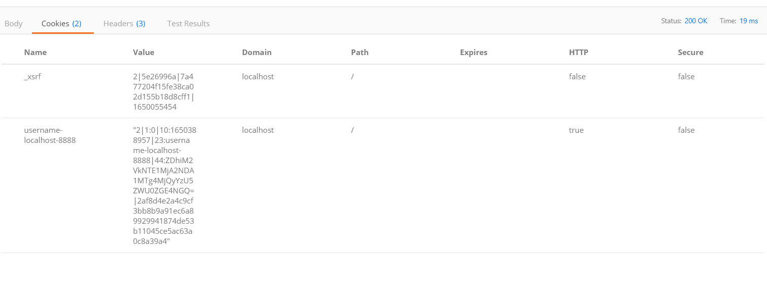

## Chat

We have implemented chat functionality for dispute queries. It utilizes Redis and web sockets.

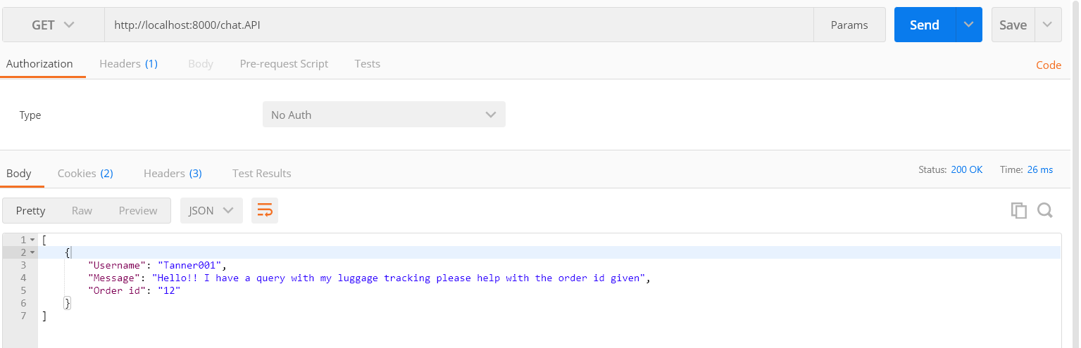

API: http://localhost:8000/chat.API

Method: GET

Status: 200->OK

If any other incompatible data is received:

404->Error

401->Unauthorized

429->Too many requests

## Basecost

End point has been created to retrieve base costs of various source destination base costs from the database.

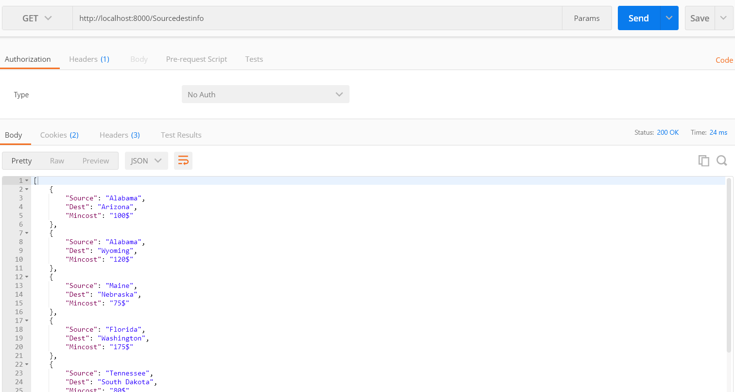

API: http://localhost:8000/Sourcedestinfo

Method: GET

Status: 200->OK

If any other incompatible data is received:

404->Error

401->Unauthorized

429->Too many requests

# Unit tests

TestLoginWrongCred: This test case passes when user gives wrong credentials

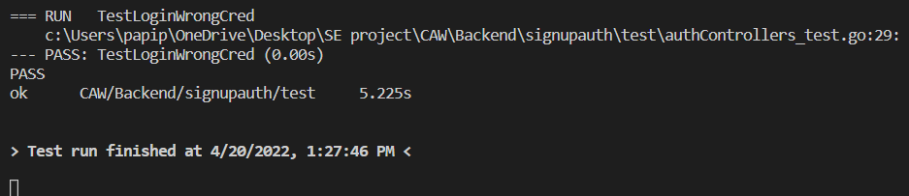

TestLogout: This test case passes when user logs out properly

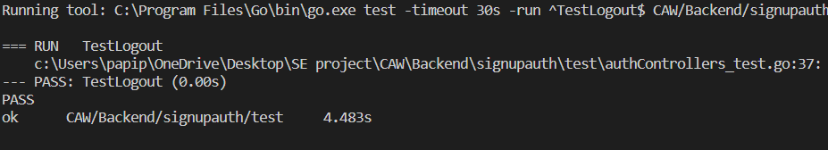

TestLogoutWhenIncorrect: This test case passes when user logs out improperly

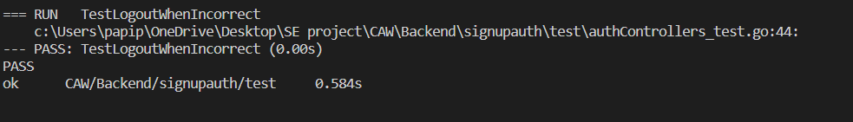

TestForgotPasswordHandler: This test case passes when user password is successfully recovered

